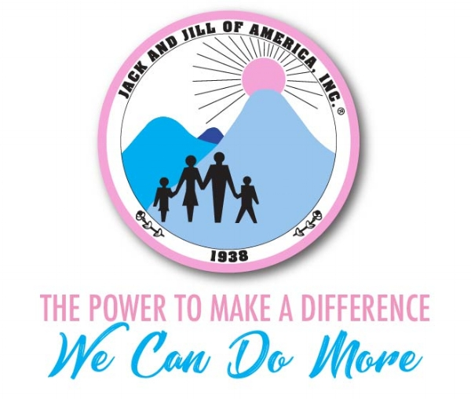

Sample Letter
Dear Senator _________,

On behalf of the Morris County Chapter of Jack and Jill of America, Inc., I am writing to ask you to support and champion the John Lewis Voting Rights Advancement Act of 2021. The African American community’s freedom to vote is under siege. Racial discrimination in voting is at an all-time high due to voter registration purges, out-of-precinct voting, and regulation of ballot collections. The John Lewis Voting Rights Act will help restore and expand the voting rights of all Americans, especially African Americans and minorities throughout this country.

Your office holds significant power in sustaining democracy, and supporting the John Lewis Voting Rights Advancement Act of 2021 is vital in the pursuit of liberty and justice for all. It is imperative that you advocate and challenge the historical barriers to voting; hold your peers accountable and remind them that protecting and expanding voting rights helps sustain our democracy.

Please advise the Senate, it’s time for them to effectively show up as a supporter in this fight. It's time to put power back in the hands of the American people. As your constituent, I urge you to use your influence to ensure the John Lewis Voting Rights Advancement Act of 2021 is passed.

Thank you,

(Name)

